HR Management System

A senior project submitted to  
Arts, Sciences & Technology University in Lebanon

for the Degree of Bachelor of Science in  
Computer and Communications Engineering

By  
Issa Abdulaziz and Issam Alsafadi

Committee Members

**Dr. Fady Halabi Supervisor**

Department of Computer and Communications Engineering  
Faculty of Engineering   
Arts, Sciences & Technology University in Lebanon   
February 2022

Project Release Form

We, (Issa Abdulaziz and Issam Alsafadi) here by release, insure, and hold harmless the Arts, Sciences & Technology University in Lebanon from any and all liability, thereof to use and publish my personal work, with identification of me by name.

Signature…………………………………………. Date..........................................

Dedication

We want to dedicate our project to our family.

Acknowledgements

First, we would like to thank our university higher management, our project supervisor Dr. Fady Halabi for his advice, and support.

Also, we would like to thank our family and friends who never get tired of motivating us to complete this project in a better way.

Abstract

As a Humane Resource, one of the biggest issues that get him confused is processing payroll, that he needs to be accurate where one small mistake and the entire operation will go downhill. Here comes the idea of mind where, why not letting this process done automatically using a web application. A web application that calculates the net salary for the employee according on his actual salary, advanced payment, leeway and overtime. In addition to managing vacations and getting different statistics about employees. To complete this web application, we have used tools like Laravel 8 as a backend framework, Html-Css-Js-JQuery-AJAX-Bootstrap-Datatable Js-Chart Js for frontend and lastly PHPMyAdmin as a database server. Throughout this report, we are going to discuss each point in this web application by the help of some screenshots.

Keywords: Html, Css, JQuery, Bootstrap, Datatable Js, Chart Js, Laravel, PHPMyAdmin, Humman Resource.

Table of Contents

Project Release Form 2

Dedication 3

Acknowledgements 4

Abstract 5

Chapter I Introduction 9

Chapter II State of the Art 10

Chapter III Report Body 11

III.1 System Feature 11

III.2 Database 12

III.3 Employee 12

III.4 Setting 15

III.5 Advanced Payment 16

III.6 Overtime 17

III.7 Vacation 18

III.8 Work Shift 19

III.9 Attendance 20

III.10 Salary 21

III.11 Home 22

Conclusion 23

Future Works 24

References 25

List of figures

Figure **Error! No text of specified style in document.**‑1 Database Diagram 12

Figure **Error! No text of specified style in document.**‑2 Employee Form 13

Figure **Error! No text of specified style in document.**‑3 Employee Profile 14

Figure **Error! No text of specified style in document.**‑4 Setting Form 15

Figure **Error! No text of specified style in document.**‑5 Advanced Payment Table 16

Figure **Error! No text of specified style in document.**‑6 Advanced Payment Form 16

Figure **Error! No text of specified style in document.**‑7 Overtime Table 17

Figure **Error! No text of specified style in document.**‑8 Overtime Form 17

Figure **Error! No text of specified style in document.**‑9 Vacation Table 18

Figure **Error! No text of specified style in document.**‑10 Vacation Form 18

Figure **Error! No text of specified style in document.**‑11 Work Shift Table 19

Figure **Error! No text of specified style in document.**‑12 Work Shift Form 19

Figure **Error! No text of specified style in document.**‑13 Attendance Form 20

Figure **Error! No text of specified style in document.**‑14 Salary 21

List of Abbreviations

|  |  |
| --- | --- |
| Html | Hypertext transfer language |
| CSS | Cascade style sheet |
| Js | JavaScript |
| Ajax | A synchronous JavaScript and XML |
|  |  |

1. Introduction

This web application, as explained before, automatically calculate the net salary according to the employee actual salary, leeway, advanced payment, and overtime. Therefore, it permits to enter different employee information and basically the salary, also the information needed for the overtime (number of hours, rate), attendances, coming and leaving time and other stuff such as vacations. According to this information the net salary is calculated.

1. State of the Art

In this web application project, we are using many tools such as following.

AJAX: Ajax allows web pages to be updated asynchronously by exchanging data with a web server behind the scenes. This means that it is possible to update parts of a web page, without reloading the whole page. [1]

Bootstrap: It quickly design and customize responsive mobile-first sites with Bootstrap, the world’s most popular front-end open-source toolkit, featuring Sass variables and mixins, responsive grid system, extensive prebuilt components, and powerful JavaScript plugins. [2]

jQuery: It is a fast and concise JavaScript Library created by John Resig in 2006 with a nice motto: Write less, do more. jQuery simplifies HTML document traversing, event handling, animating, and Ajax interactions for rapid web development. jQuery is a JavaScript toolkit designed to simplify various tasks by writing less code [3]

DataTables: It is a plug-in for the jQuery Javascript library. It is a highly flexible tool, built upon the foundations of progressive enhancement, that adds different advanced features to any HTML table. [4]

Chart.js: It is an easy way to include animated, interactive graphs on your website for free. [5]

Laravel: It is a simple PHP framework frequently used for web application development that is known for its exceptional characteristics like reliability, high performance, finer efficiency, articulated ORM systems, a multiplicity of Authentication options, expandability, modularity, facilitates caching, secure SQL processing, dedicated SQL builder, restful controller, uncomplicated coding rules, etc. [6]

XAMPP: It is one of the widely used cross-platform web servers, which helps developers to create and test their programs on a local webserver. [7]

1. Report Body
   1. System Feature

This system has many features and mini features but let us focus on the main one:

1. Add/ Edit/ Delete Employees
2. Add/ Edit/ Delete Overtimes
3. Add/ Edit/ Delete vacations
4. Add/ Edit/ Delete work shifts
5. Add/ Edit/ Delete Advanced Payments
6. Add/ Edit/ Delete Daily Attendances
7. Set Starting Time (Time at which the employee start working)
8. Set End Time (Time at which the employee leave)
9. Set the Weekend
10. Set Overtime Rate
11. Set Weekend Overtime Rate
12. Set Leeway Discount Rate
13. Set vacation increment rate
14. Set Working Start Time
15. Set Working End Time
16. Calculating Net Salary
17. Exporting data to excel
18. Print data
19. Employee profile
20. Some statistic and charts
    1. Database

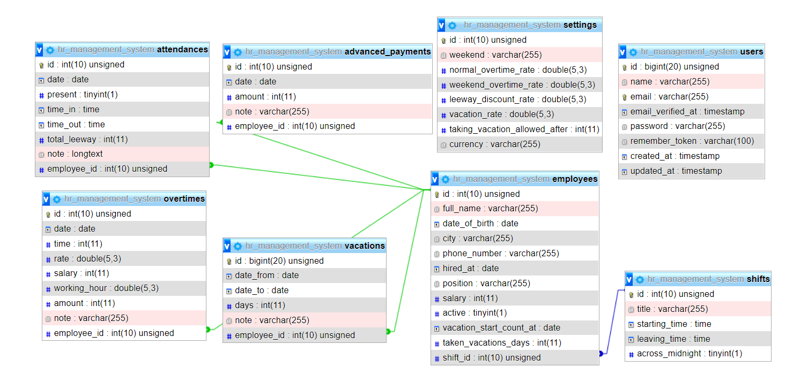

Figure **Error! No text of specified style in document.**‑ Database Diagram

This is the database diagram where there are one to many relationship between employees table and advanced_payments, attendances, overtimes, and vacations tables (one at employee table) also there is many to one relationship between employees table and shifts table which is for the work shifts (many at employee table). In addition to the settings and users tables.

* 1. Employee

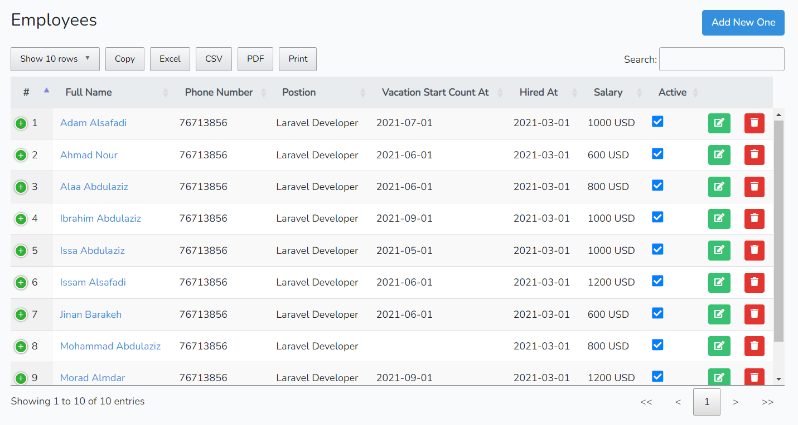In this section you will see detailed information about all employees with the ability of search, paginate, order by column, copy, export to excel, export as a pdf or printing the data. In addition to that, this table is responsive so whenever the screen size shrinks some columns will disappear but you can see them again by clicking the plus icon in the first column. Upon deleting, a confirmation message will show up to ensure you want to delete because deleting employee means also deleting all related data for this employee such as overtimes, attendances, vacations data and more. Edit and add button will open employee form which is as follow.

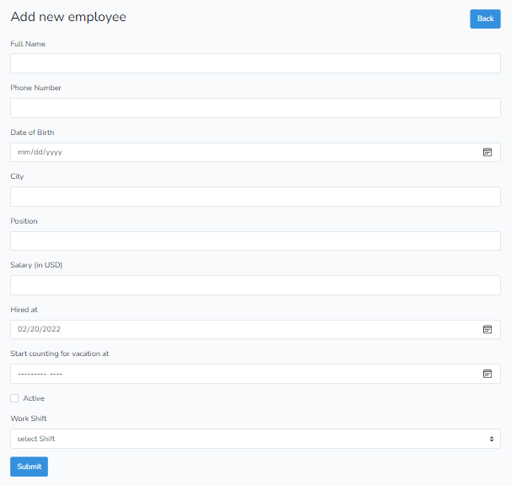

Figure **Error! No text of specified style in document.**‑ Employee Form

Let us discuss some field here. The Active check box is to inform that the employee is yet working for the company in other word if he left his job but we don’t want to delete his data we can then uncheck this field. The work shift list which is a list of all shifts added (it may be only one). Adding shifts will be discussed later. Lastly the start counting for vacation which is a date at which counting vacation will start at the rate specified in the setting we will discuss this later also.

In employee section we also have profile for each employee which can be entered by clicking the name of the employee

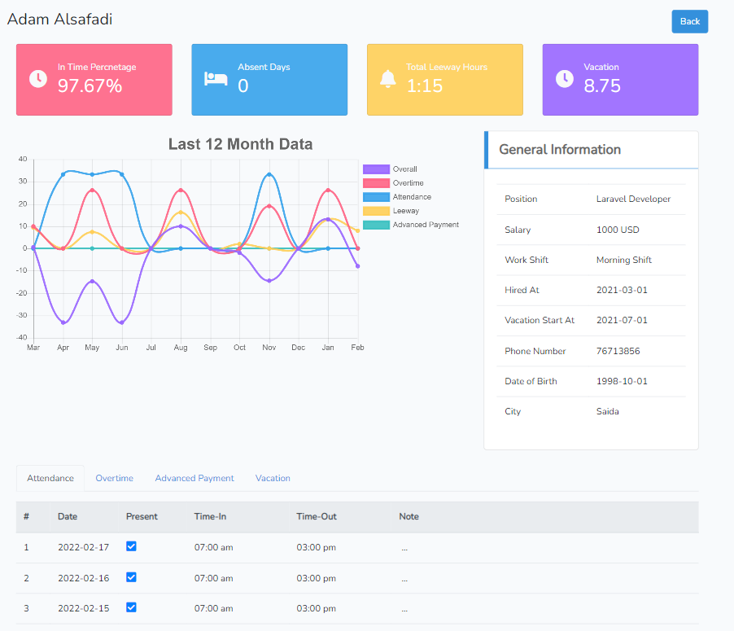

Figure **Error! No text of specified style in document.**‑ Employee Profile

The In-Time percentage card at the top is the ratio of all present days without any leeway over all present days (with and without leeway) which shows how this employee is sticked to time. The absent days card is the absent days for the current month. Total leeway hours card is also for the current month. Vacation card is the number of vacation that this employee has. Down we have a chart which is implemented using the chart Js library where the x-axis is the last 12 month and the y-axis is the amount of money. In another word this is a report for the last 12 month where for each month it shows the amount of money for different things such as leeway discount, overtime, advanced payment, discount for absent day, and the overall. Lastly, we have down different taps such as attendance tap which shows last 30 record in attendance table for this employee. Also, Overtime, advanced payment, and vacation taps which show the last 10 record in the database for this employee.

* 1. Setting

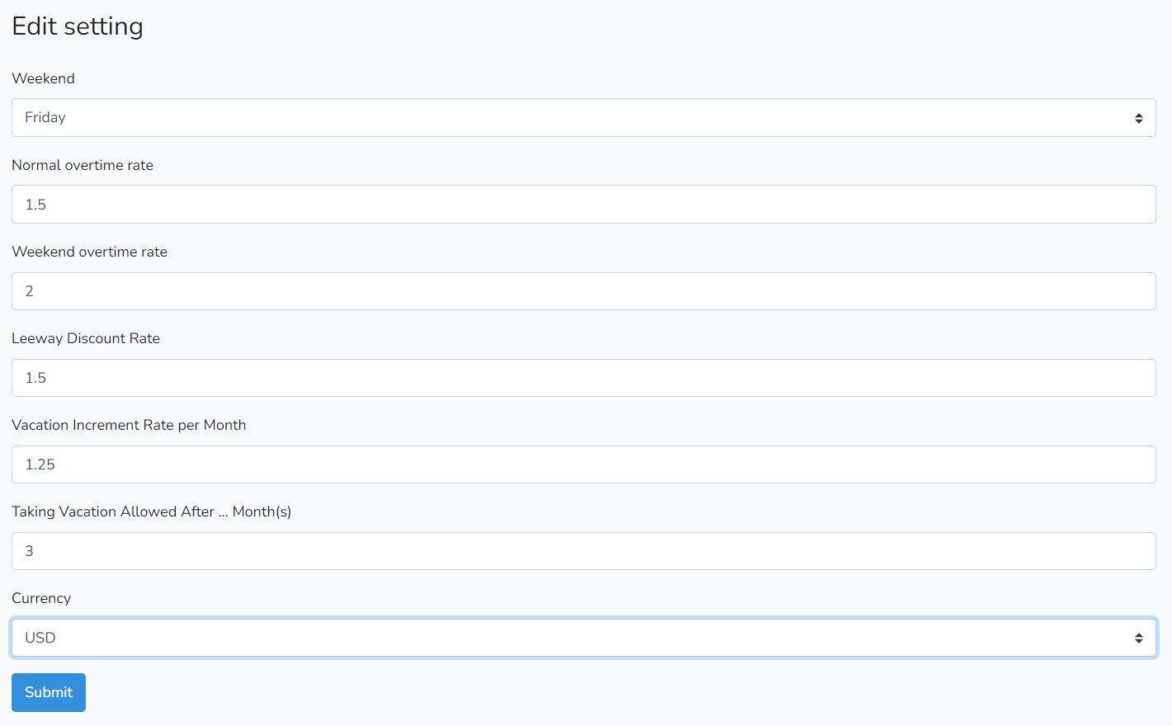

Figure **Error! No text of specified style in document.**‑ Setting Form

In this section we can set some general setting to work on such as weekend which will help us in setting the default overtime rate when adding overtime. also, in vacation to exclude the weekend day so it will not be counted. Normal and weekend overtime rate are to help us set a default rate when adding overtime. Taking vacation allowed after field is the number of months after starting to count for vacation at which he is allowed to take his vacation for example if vacation start to count for an employee at certain date, he cannot take immediately those vacations that are counted for him unless for example 3 months pass. Lastly, currency field it can be USD or LBP. Yet we have not implemented the transfer between them so at start you choose one to work with.

* 1. Advanced Payment

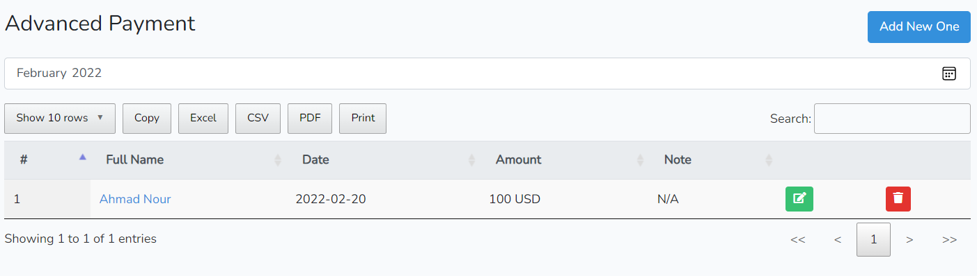

Figure **Error! No text of specified style in document.**‑ Advanced Payment Table

As we see in the employee table we have here also search, paginate, order by column, copy, export to excel, export as a pdf or printing the data. But the data showed is as the specified month “February 2022” for sure you can see the data for any month. And for the advanced payment form it is as follows.

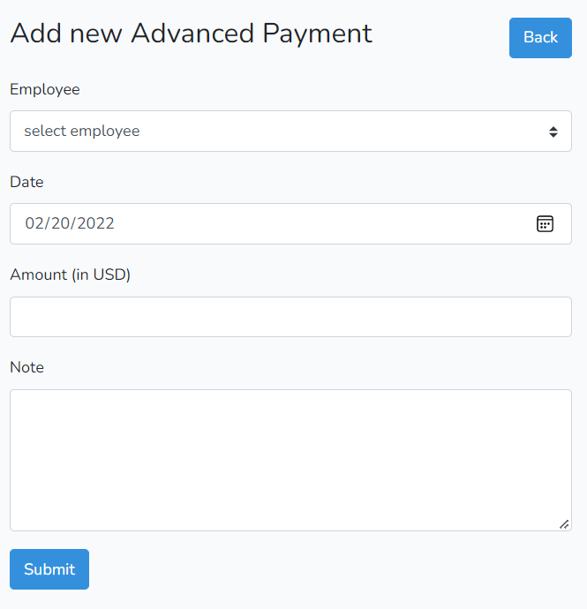

Figure **Error! No text of specified style in document.**‑ Advanced Payment Form

A list of all employee will show up. When selecting one an ajax request will be sent to get the hired at date for this employee to set the minimum value of the date field as the hired at date. In simple word employee cannot take advanced payment before he is hired.

* 1. Overtime

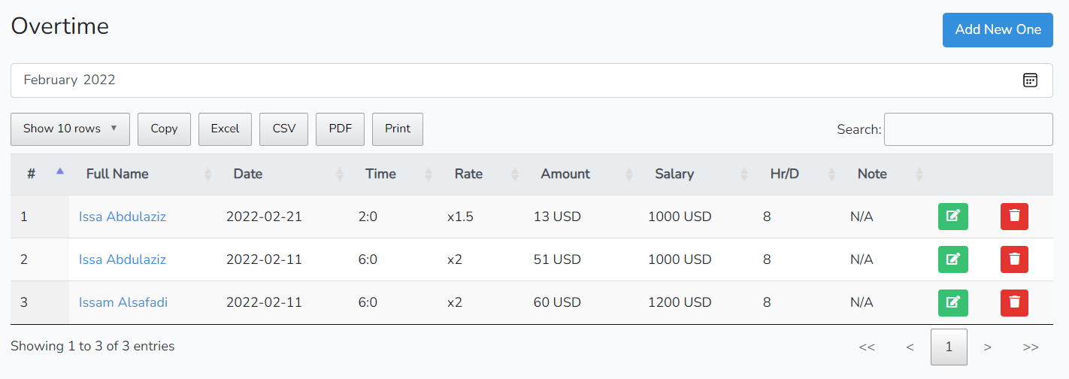

Figure **Error! No text of specified style in document.**‑ Overtime Table

As in any table we have here all mentioned function and as in advanced payment we can see overtime data by the selected month. But let us move to the overtime form.

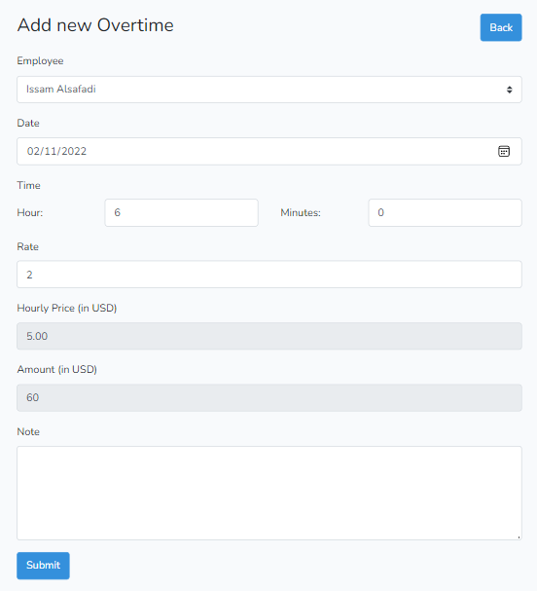

Figure **Error! No text of specified style in document.**‑ Overtime Form

Upon selecting an employee from the employee list, an AJAX request will be sent to the server to get the salary of the selected employee also to get in what shift he is so to calculate how many hours he works a day then to calculate his hourly price using the following formula (salary / 30 / working hours per day). Another AJAX request will be sent whenever the date field changed. This request is to get the default overtime rate taking into consideration that the chosen date maybe for a weekend so then the server reply with the weekend overtime rate specified in the setting. Lastly, whenever the time field (hours and minutes) changed the amount of this overtime will be calculated using this formula (hourly price * rate * time).

* 1. Vacation

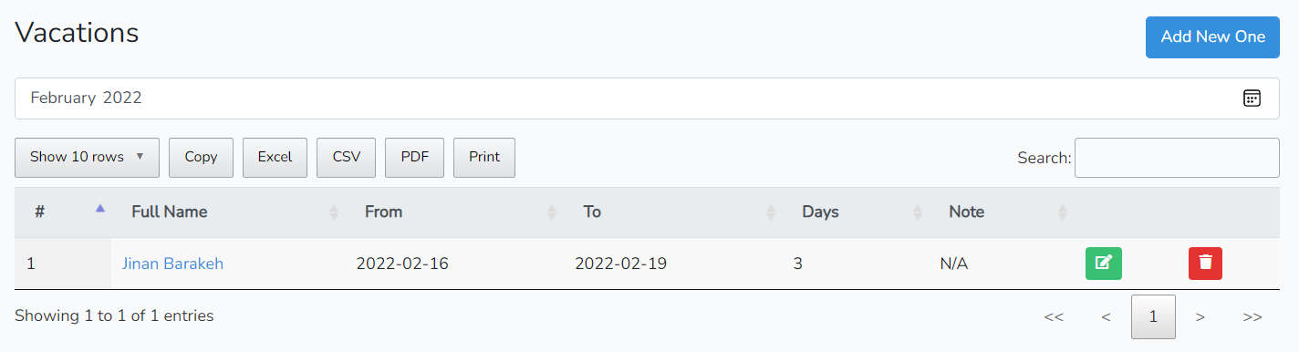

Figure **Error! No text of specified style in document.**‑ Vacation Table

As you see nothing is added here so let us focus on the vacation form.

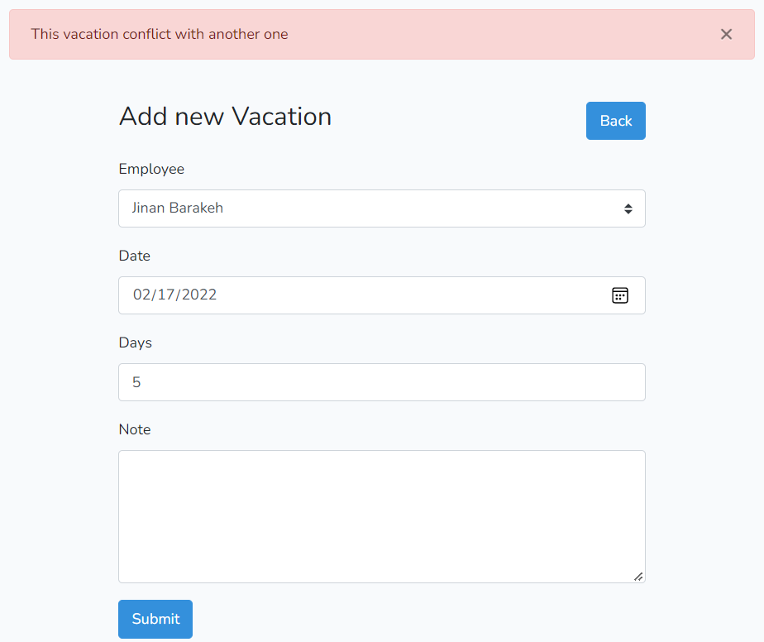

Figure **Error! No text of specified style in document.**‑ Vacation Form

First of all, in the employee list only the employee that can take vacation will appear. After selecting employee from the list, an AJAX request will be sent to get how many vacation days he has so then to set the max value of the days field as the number of vacation days this employee can take. Also, to get the date at which he can take vacation after it. This date is calculated using two things. One is the “vacation start counts at” date which is specified in the employee form. The other is the “taking vacation allowed after” (specified in setting) which is the number of months to be passed after start counting for vacation so then the employee can take vacation. for example, if taking vacation allowed after 12 months, and vacation of an employee start to counts at 2021/1/1 then he cannot take vacation before 2022/1/1. So now the minimum value of the date field is set to the date at which he can take vacation after it. Moving to the logic behind the submit button. After submitting the data, it first checks if this employee has any vacation that conflict with the one to be submitted. If not, it saves the data but also it adds the vacation days to the total taken vacation days of that employee which help us to calculate how many vacation days he can take next time. In addition to that, we cannot take attendance to this employee within the vacation instead it fills it automatically as an absent day but all absent days that are because of any vacation will not affect the net salary.

* 1. Work Shift

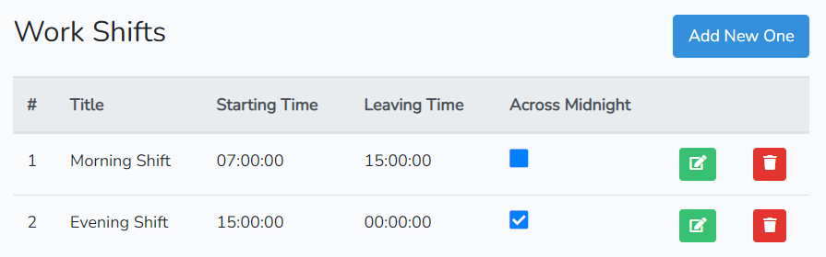

Figure **Error! No text of specified style in document.**‑ Work Shift Table

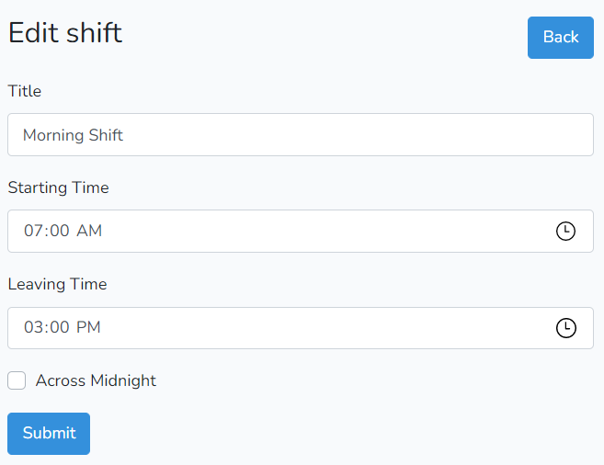

Figure **Error! No text of specified style in document.**‑ Work Shift Form

The only thing to be discussed here is the “across midnight” option. Where in any shift that crosses midnight, this option should be checked. It is very important to check it and let us say why using an example. Let’s say that the leaving time is at 1:00 am which is in a new day when an employee leaves the work at 11:00 pm then there should be 2 hours to be discount but when calculating it using php DateTime class it appears that 22 hours are to be discount. Yes, we want the difference between two times but not like this way so we use across midnight option to take 2 hours not 22 hours.

* 1. Attendance

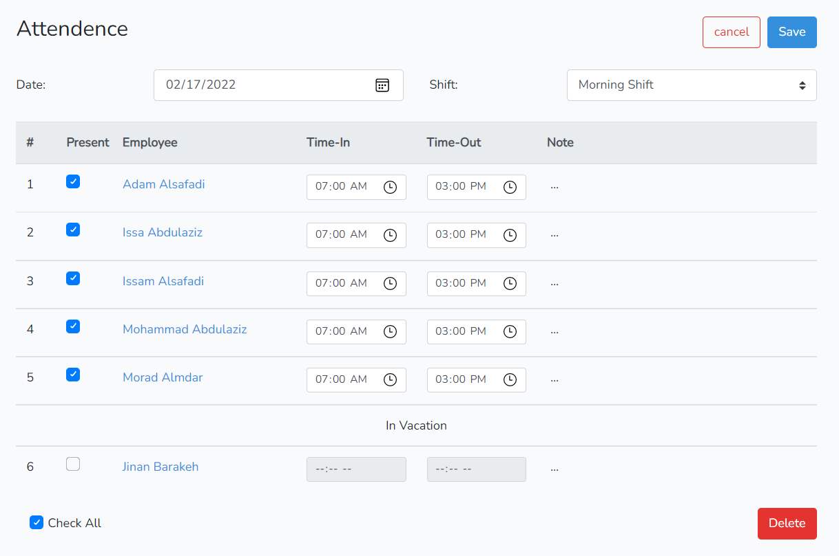

Figure **Error! No text of specified style in document.**‑ Attendance Form

As discussed before in vacation section, we cannot edit the information of an employee that is in vacation and when saving the attendance, he will be absent as default. When checking the present option for an employee his time-in and time-out will be filled as starting time and leaving time of his work shift respectively. For sure it can be edited. When saving the attendance, the leeway will be calculated for each employee so then to be saved with all information in the database.

* 1. Salary

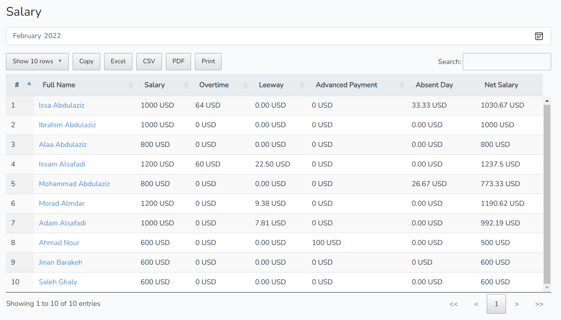

Figure **Error! No text of specified style in document.**‑ Salary

In this section the net salary is calculated based on the salary of the employee, total overtime amount, total leeway discount, absent day (that are not because of a vacation) discount and taken advanced payment for the selected month.

* 1. Home

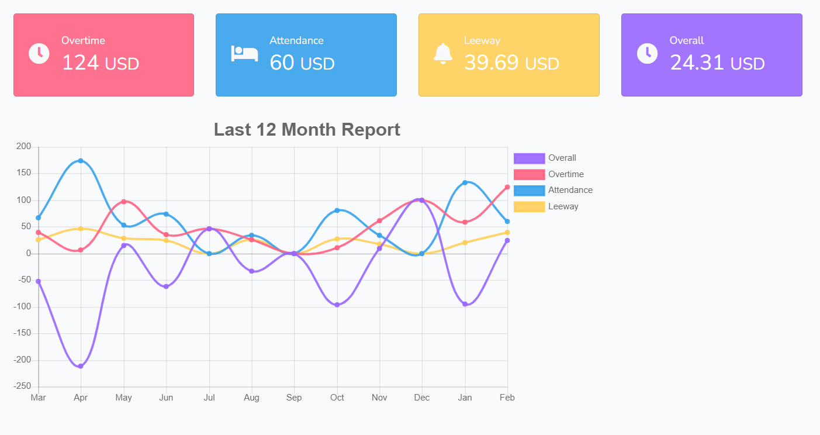

Figure **Error! No text of specified style in document.**‑ Home Page

In the home section we will see data that is the overall for all employee. For example, the cards at the top which are the data for the current month they mean as follows. The overtime card shows the total overtime amount that will be paid for employees within this month, absence card shows the total discount for all employee related to being absent, leeway card shows the total leeway discount for all employee within this month also, lastly the overall card which is the overtime amount – absence discount – leeway discount. And for the chart down below it shows the same data but for the last 12 month.

Conclusion

As a conclusion, we can say that by using this system we can avoid manual problems and also documentation storage problem we can’t maintain long period data that’s why we used computerized system to overcome all problem related to computing the net salary for the employee.

Future Works

Still, this system has not totally completed. But we are looking now to implement more features like making the weekend flexible in case of different employee have different weekend like in supermarket and adding the ability to add more than one weekend for each employee like in a hospital where for example nurses have 3 days off each week. In addition to making the system adaptable with part-time employees. Not to mention using fingerprint will make this system a lot easier when taking attendance.

References

|  |  |
| --- | --- |
| [1] | "What is AJAX," [Online]. Available: https://www.w3schools.com/whatis/whatis_ajax.asp. |
| [2] | "get started with bootstrap," [Online]. Available: https://getbootstrap.com/. |
| [3] | "What is JQuery?," [Online]. Available: https://www.tutorialspoint.com/jquery/jquery-overview.htm. |
| [4] | "Datatable js," [Online]. Available: https://www.datatables.net/. |
| [5] | [Online]. Available: https://www.chartjs.org. |
| [6] | "What is Laravel," [Online]. Available: https://www.educba.com/what-is-laravel/?source=leftnav. |
| [7] | "XAMPP TUTORIAL," [Online]. Available: https://www.javatpoint.com/xampp#:~:text=XAMPP%20is%20one%20of%20the%20widely%20used%20cross-platform,can%20be%20revised%20or%20modified%20by%20the%20audience.. |